Discussion: Television and Digital Marketing Pros and Cons and Brands that Uses Them
Student’s Name
Institutional Affiliations

Discussion: Television and Digital Marketing Pros and Cons and Brands that Uses Them
The pro of using television for marketing lies in its ability to reach larger audience simultaneously. As a marketing manager, strategizing the most watched television station is the breakthrough for my company as shown by Marone (2017). Equally, marketing through television medium creates repeated persuasion that possibly familiarizes my products in the market. Moreover, televisions commercials are easier to analyze for they appeal to many human senses. People like what they get see and internalize how it functions. This is good for creating trust and reputation for my company. Marone (2017) also describes that the sensual appeal of products on television is advantageous for the viewers to make informed decisions on whether to purchase or wait to compare prices across the market.
On the other hand, repetition of television commercials within given prime times can be expensive to maintain when the set objectives for marketing have not been achieved. In the same way, using television for general marketing may fail to reach a specifically targeted group. The commercials that are run on the television are, in most cases, very randomized, leaving it as a matter of chance to catch the attention of the targeted group of customers. Alobaidi (2018) asserts that marketing managers must use a different stream of advertisement simultaneously with the television adverts so as not to miss out on one’s audience. In the long run, it still sums up in extreme expenses.
Digital marketing through social media creates an analysis of consumer data to be effectively achievable. For instance, if my target group is the millennial, then using time-bound objectives can prove useful in determining the progress made in marketing through a chosen website (Girchenko & Ovsiannikova, 2016). Consumer behaviors, preferences, needs and expectations can be derived from customers’ pages allowing the company to be ahead in providing only what customers directly need. Digital marketing is also cost-effective for a similar commercial that can be posted on several social media pages of the company. Conversely, digital marketing can be prone to identity and brand theft. Over the years, cyber insecurity has risen with advancements correspondingly being made from technology changes. Companies and individuals who transact on digital media have, in one way or another, suffered from identity imitation to defraud unknowing customers. When systems are jammed or need software upgrading, digital marketing may also prove to be unreliable.
Business Brands that Make Use of Television and Digital Marketing
Coca Cola is very famously known for its sugar-free hyped television commercials. This company has also obtained its customization of product value by encoding customers’ names on the brims of their plastic cans. Additionally, it has achieved market optima through televised collaborations in the fight against environmental degradation. The company’s commercials that depict family bonding times with “Cold Cock” adverts have been a strategy that has made the product a household item. On the other hand, Uber has been around for a few years and it is very famously active on social media, as shown by Alobaidi (2018). It is a brand that is technology-assisted means of transport all around major cities. The company has utilized social media pages including Instagram, Facebook and Twitter. Both television and digital marketing approaches have created impeccable growth for the two leading brands, respectively.
Screenshot for Digital Marketing and Television Marketing
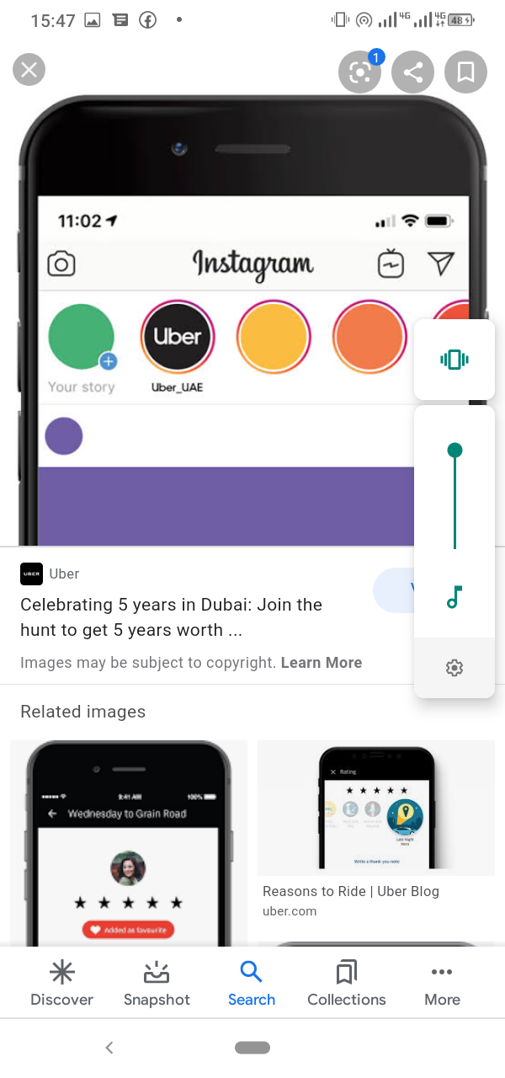
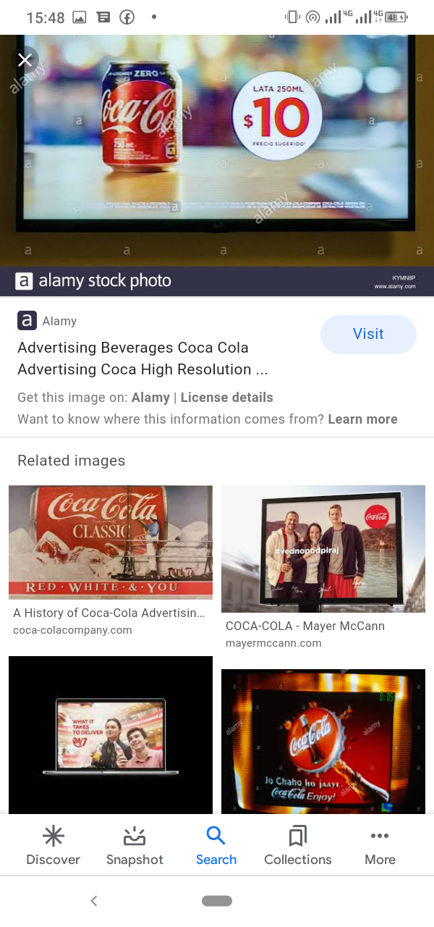
References
Alobaidi, E. (2018). Outline to the advantages and disadvantages of social media. Academicia: An International Multidisciplinary Research Journal, 8(4), 4-11.
Girchenko, T., & Ovsiannikova, Y. (2016). Digital Marketing and its Role in the Modern Business Processes. European Cooperation, 11(18), 24-33.
Marone, V. (2017). The discursive construction of meaning across texts and media. Social Sciences and Education Research Review, 4(2), 42-77.

